Problem 1

According to what I got from normal probabilities and this graph I think the Arbys’s restaurant is the closest distribution to normal.

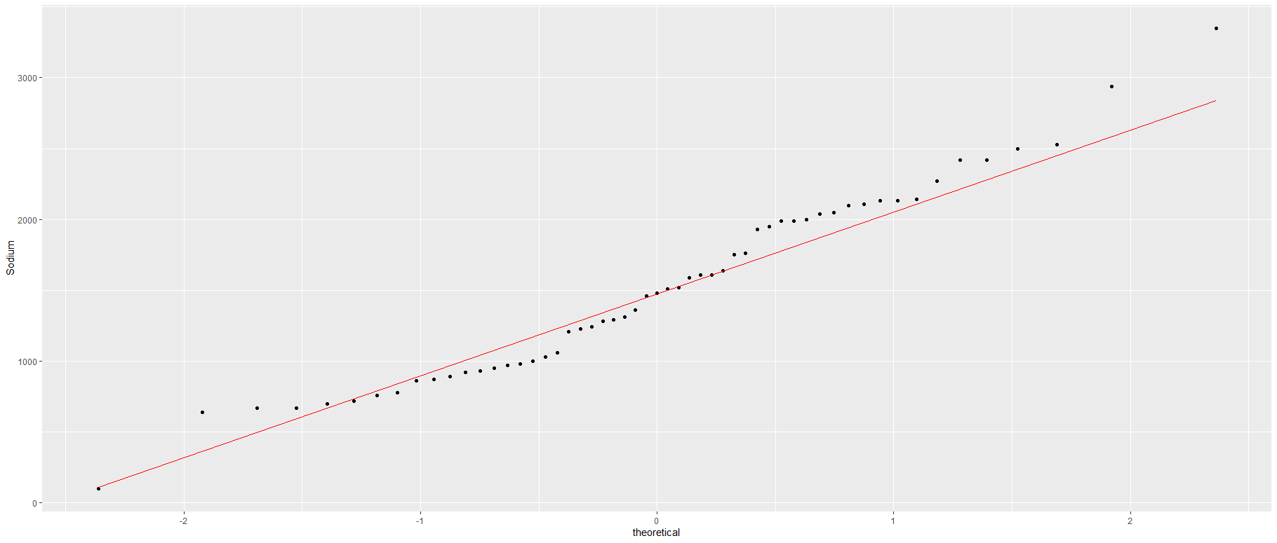

Problem 3

Here is the ggplot I have used to create a histogram for the total carbohydrates of my favourite restaurant which is Burger King. If we draw a line on this graph, we’ll get a left-skewed graph.

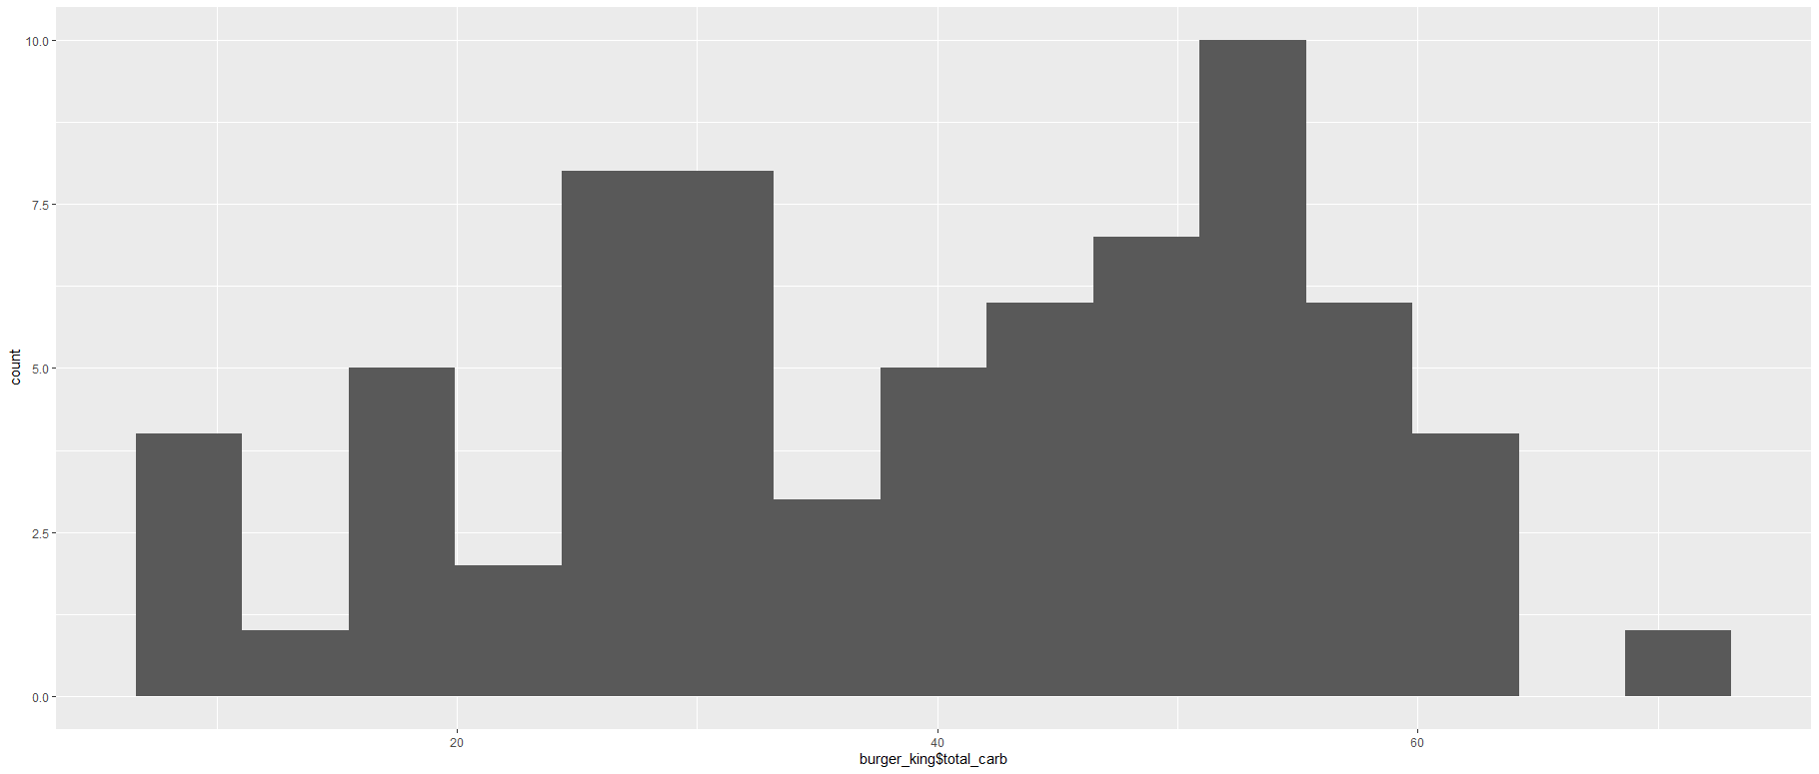

Thank you

Student ID : 201923250

Name : Kobilov Ilkhomjon